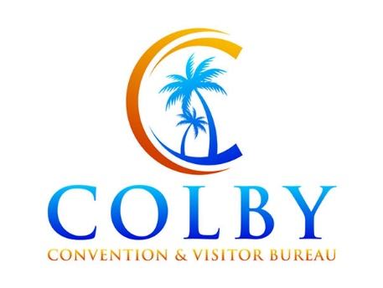**Join Our Team: Executive Director - Colby Convention & Visitors Bureau, Colby, KS**

Are you passionate about promoting conventions and tourism in a vibrant community? The Colby Convention & Visitors Bureau is seeking a qualified individual to serve as the Executive Director to lead our team.

**Responsibilities:**

* Develop and implement strategic plans to attract visitors and promote Colby as a premier choice for tourism, events, meetings, and conventions.
* Oversee marketing initiatives, including advertising via digital marketing, and social media engagement.
* Cultivate relationships with local businesses and organizations, attractions, and community members to enhance tourism offerings.
* Manage bureau operations, including budgeting, staff supervision, and reporting to the board of directors.
* Represent Colby at events, conferences, and trade shows to enhance visibility and networking opportunities.

**Qualifications:**

* Excellent communication and interpersonal skills, with the ability to collaborate effectively with diverse stakeholders.
* Knowledge of industry trends and marketing techniques.
* Strong strategic planning and organizational skills with the ability to drive results.
* Ability to travel and work evenings and weekends as necessary for meetings and events.

If you're ready to make a positive impact on tourism in Colby and lead our bureau to new heights, we want to hear from you! Please submit your resume and cover letter detailing your qualifications and vision for the role to: [convention@st-tel.net](mailto:convention@st-tel.net).

Join us in showcasing all that Colby has to offer and creating unforgettable experiences for visitors from near and far. Let's build a brighter future for tourism together! Apply now to become our next Executive Director.